1. Create Table Name : Student and Exam

* ADD Foreign key

[ALTER](http://localhost/phpmyadmin/url.php?url=https://dev.mysql.com/doc/refman/8.0/en/alter-table.html) [TABLE](http://localhost/phpmyadmin/url.php?url=https://dev.mysql.com/doc/refman/8.0/en/alter-table.html) `exam` ADD FOREIGN KEY (`Rollno`) REFERENCES `student`(`Rollno`);

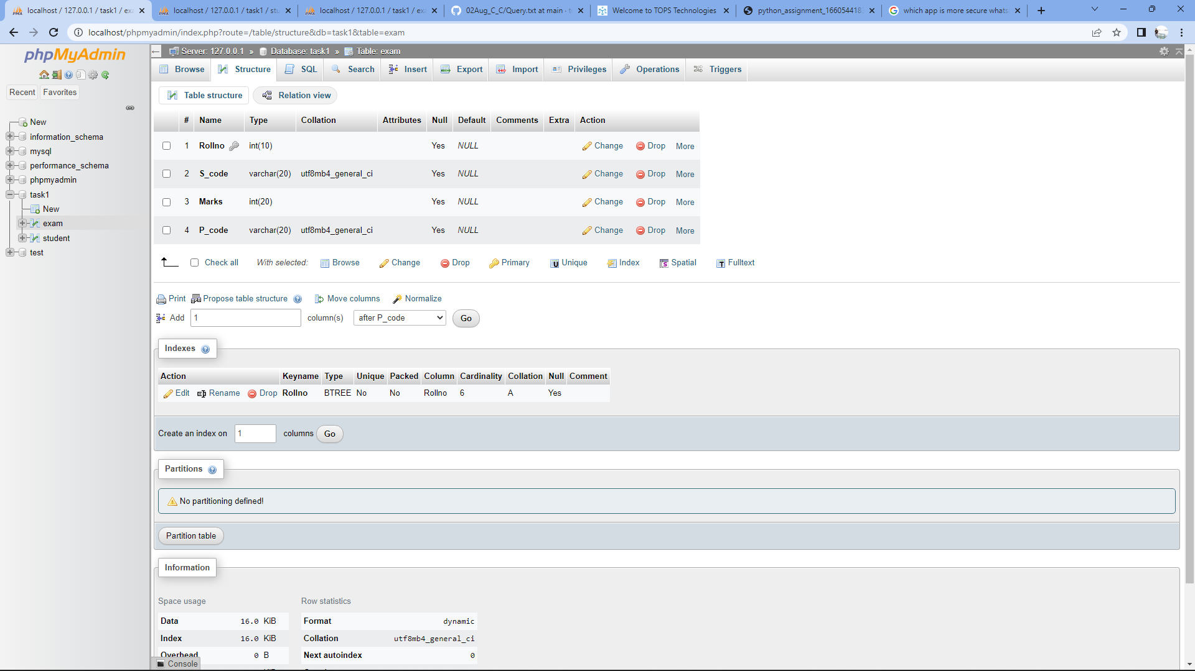

3) Create table given below: Employee and Incentive

[CREATE](http://localhost/phpmyadmin/url.php?url=https://dev.mysql.com/doc/refman/8.0/en/create-table.html) [table](http://localhost/phpmyadmin/url.php?url=https://dev.mysql.com/doc/refman/8.0/en/create-table.html) `Employee` ( Employee_id int(10), First_name varchar(50), Last_name varchar(50), Salary int(50), Joinning_date varchar(20), Department varchar(20) );

[ALTER](http://localhost/phpmyadmin/url.php?url=https://dev.mysql.com/doc/refman/8.0/en/alter-table.html) [TABLE](http://localhost/phpmyadmin/url.php?url=https://dev.mysql.com/doc/refman/8.0/en/alter-table.html) `employee` ADD `Salary` int(50) AFTER `Department`

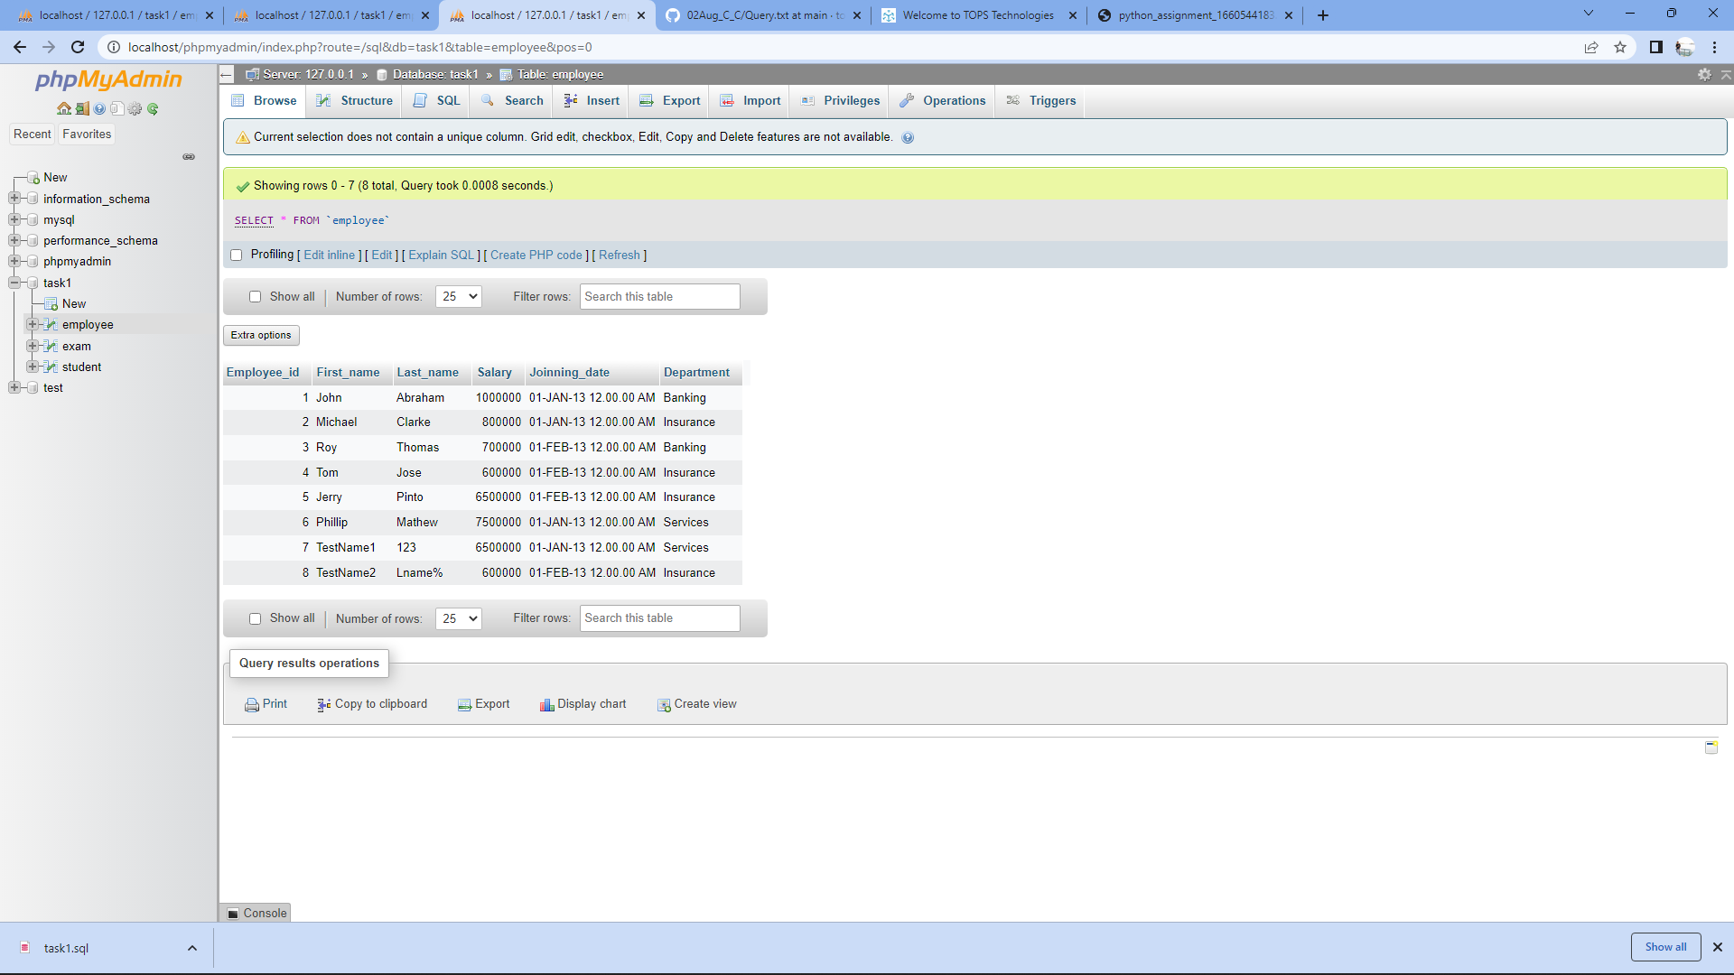

a) Get First_Name from employee table using Tom name “Employee Name”.

[SELECT](http://localhost/phpmyadmin/url.php?url=https://dev.mysql.com/doc/refman/8.0/en/select.html) First_name "Employee Name" FROM `employee`;

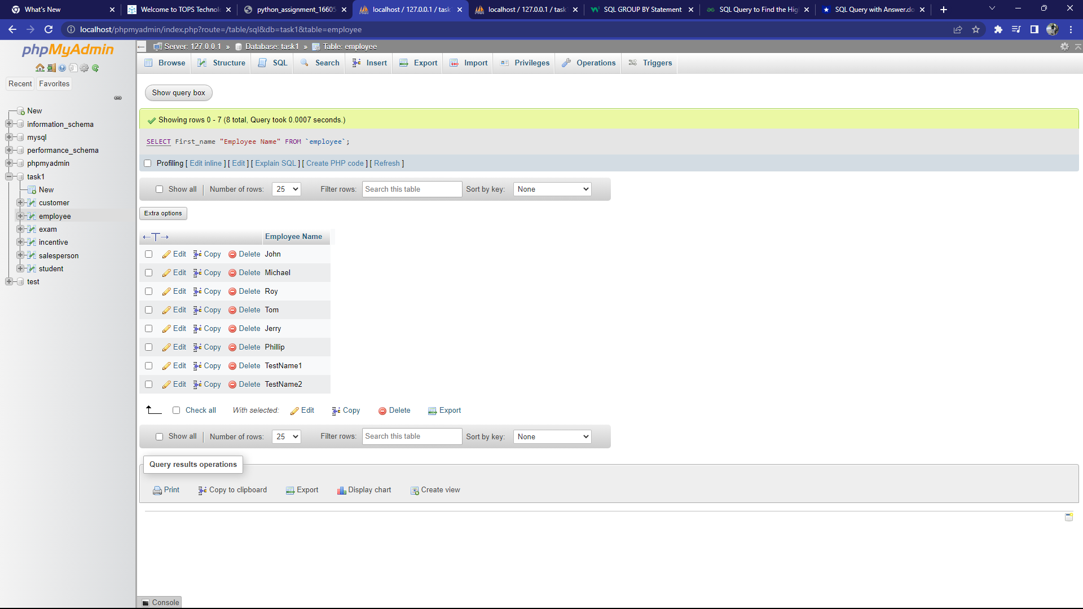

b) Get FIRST_NAME, Joining Date, and Salary from employee table.

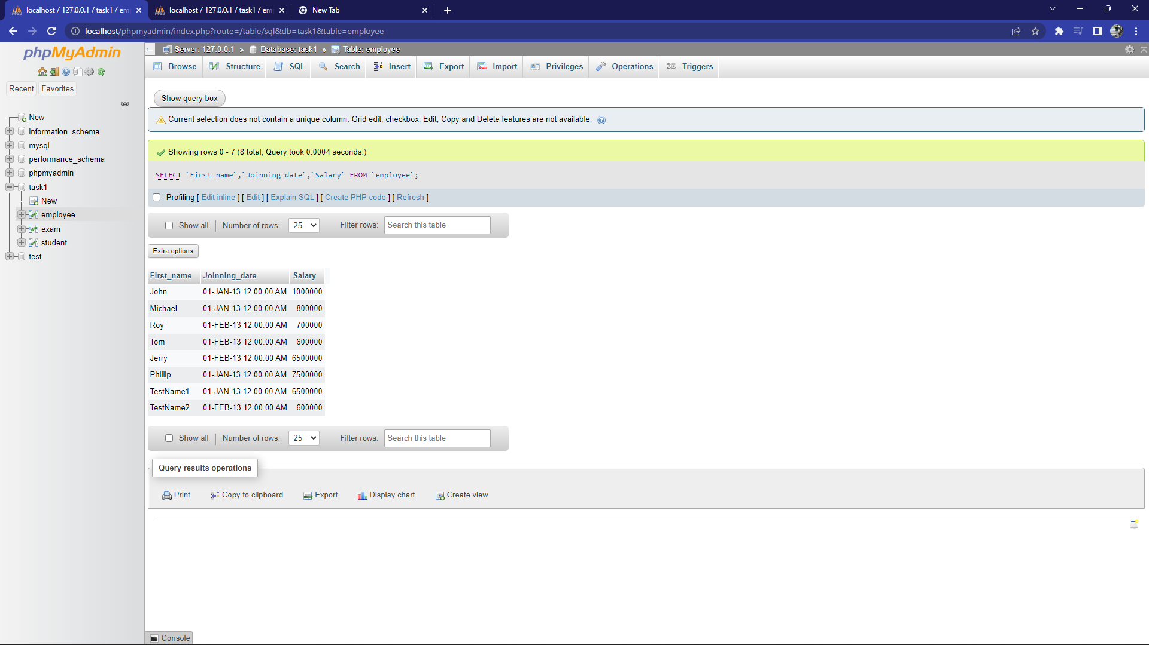

c) Get all employee details from the employee table order by First_Name Ascending and Salary descending?

[SELECT](http://localhost/phpmyadmin/url.php?url=https://dev.mysql.com/doc/refman/8.0/en/select.html) * FROM `employee` ORDER BY First_name ASC , Salary DESC;

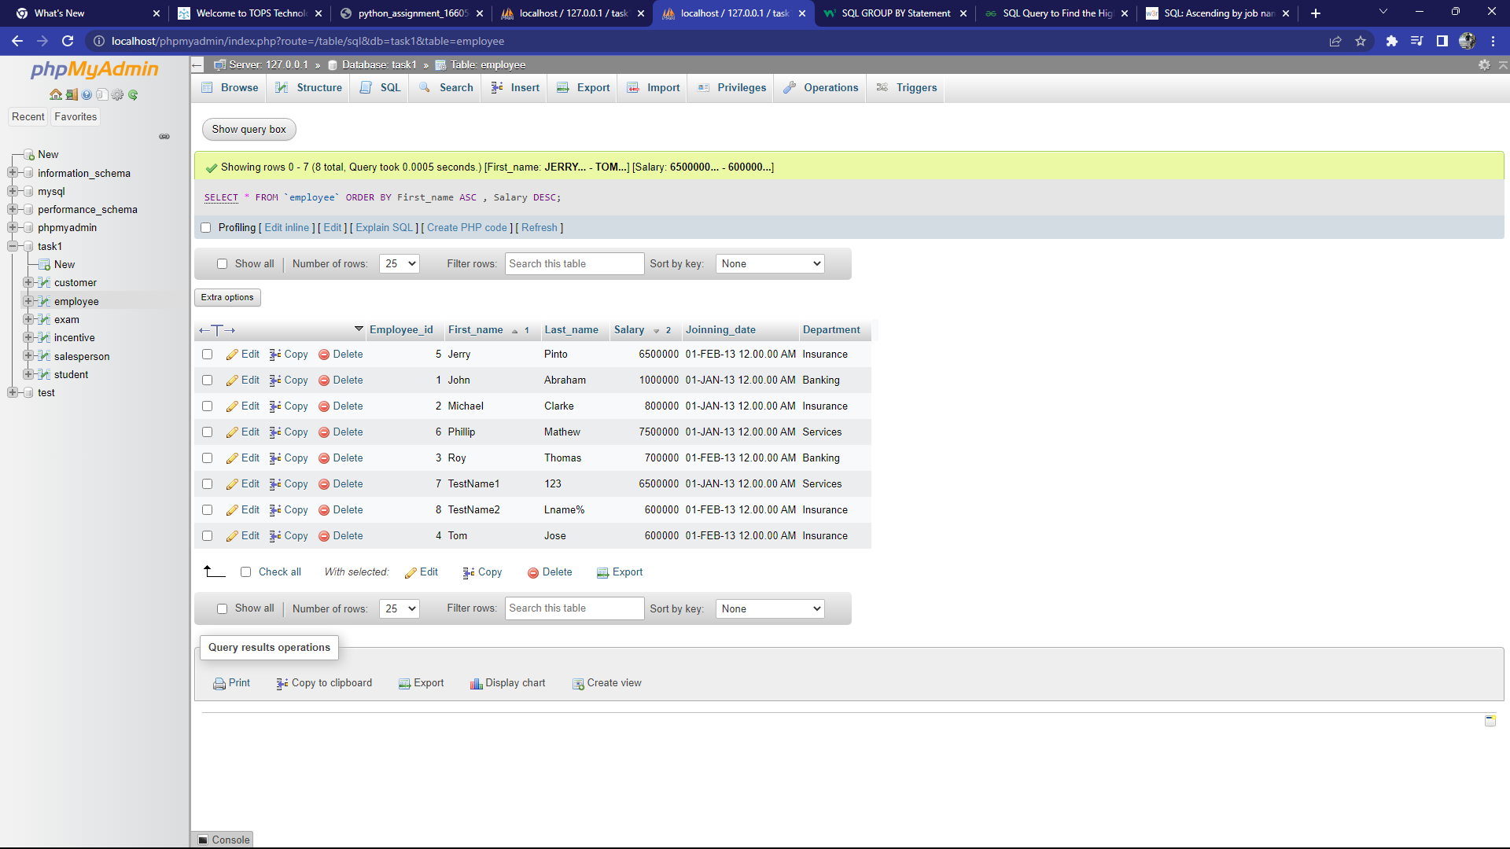

d) Get employee details from employee table whose first name contains ‘J’

[SELECT](http://localhost/phpmyadmin/url.php?url=https://dev.mysql.com/doc/refman/8.0/en/select.html) * FROM `Employee` WHERE `First_name` [LIKE](http://localhost/phpmyadmin/url.php?url=https://dev.mysql.com/doc/refman/8.0/en/string-comparison-functions.html%23operator_like) 'J%';

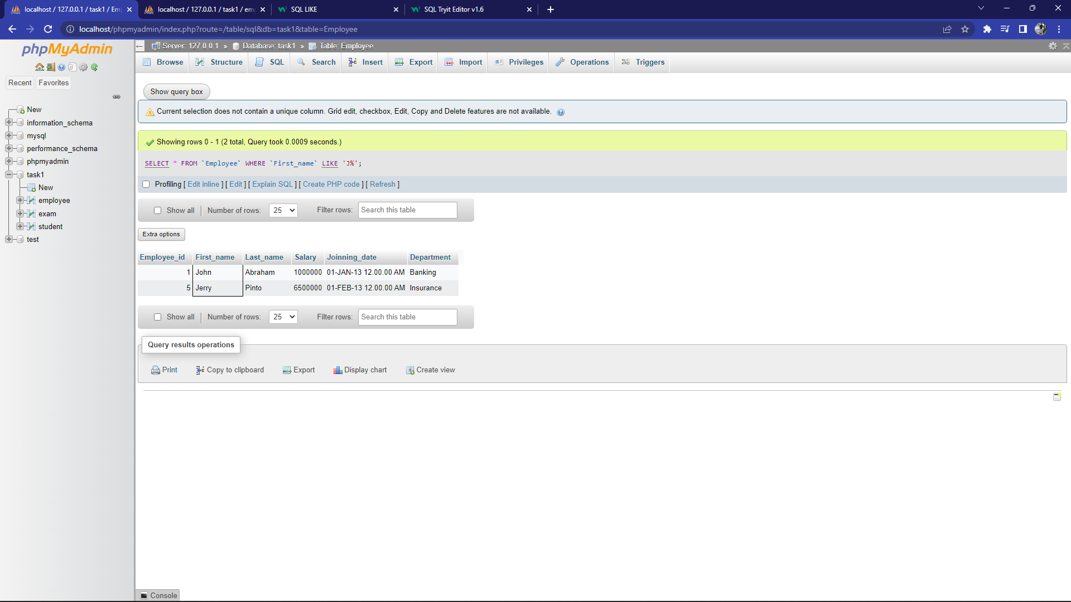

e) Get department wise maximum salary from employee table order by salary ascending?

[SELECT](http://localhost/phpmyadmin/url.php?url=https://dev.mysql.com/doc/refman/8.0/en/select.html) `Department`,[MAX](http://localhost/phpmyadmin/url.php?url=https://dev.mysql.com/doc/refman/8.0/en/aggregate-functions.html%23function_max)(Salary) FROM `employee` GROUP by `Department` ORDER BY [MAX](http://localhost/phpmyadmin/url.php?url=https://dev.mysql.com/doc/refman/8.0/en/aggregate-functions.html%23function_max)(Salary) ASC;

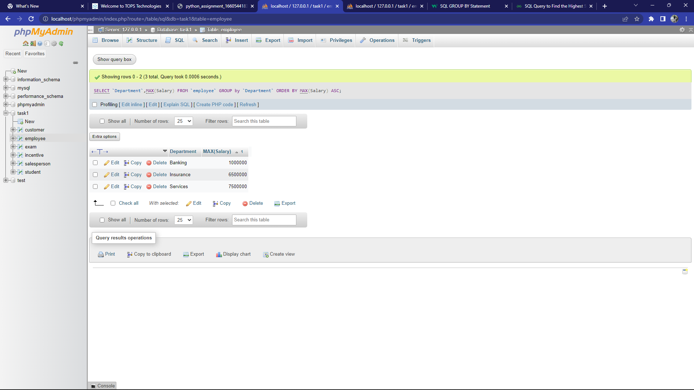

f) Select first_name, incentive amount from employee and incentives table for those employees who have incentives and incentive amount greater than 3000

[SELECT](http://localhost/phpmyadmin/url.php?url=https://dev.mysql.com/doc/refman/8.0/en/select.html) employee.`First_name`,incentive.Incentive_amount FROM `employee` INNER JOIN incentive ON `Employee_id`=`Employee_ref_id` WHERE incentive.Incentive_amount > 3000;

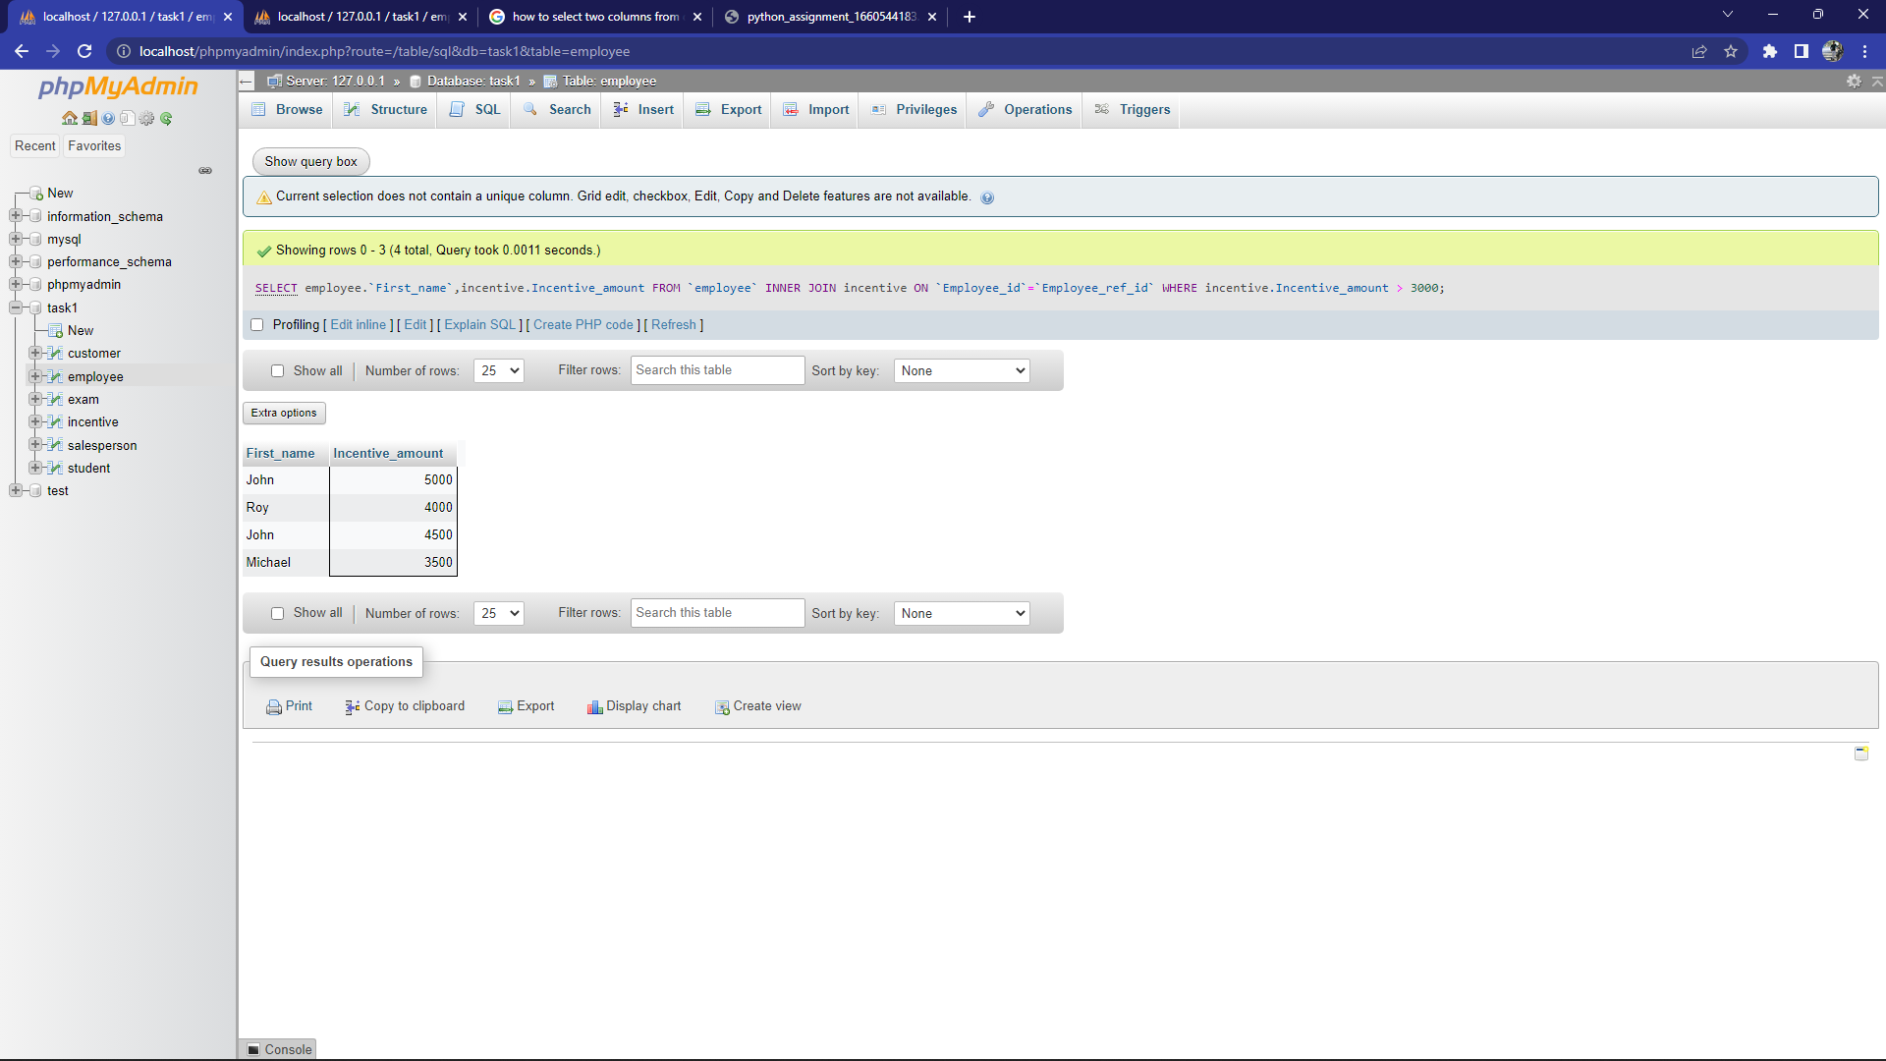

4. Create table given below: Salesperson and Customer

b) Names and cities of all salespeople in London with commission above 0.12

[SELECT](http://localhost/phpmyadmin/url.php?url=https://dev.mysql.com/doc/refman/8.0/en/select.html) SNAME,CITY,COMM FROM `salesperson` where CITY ='london' [AND](http://localhost/phpmyadmin/url.php?url=https://dev.mysql.com/doc/refman/8.0/en/logical-operators.html%23operator_and) `COMM` >= 0.12;

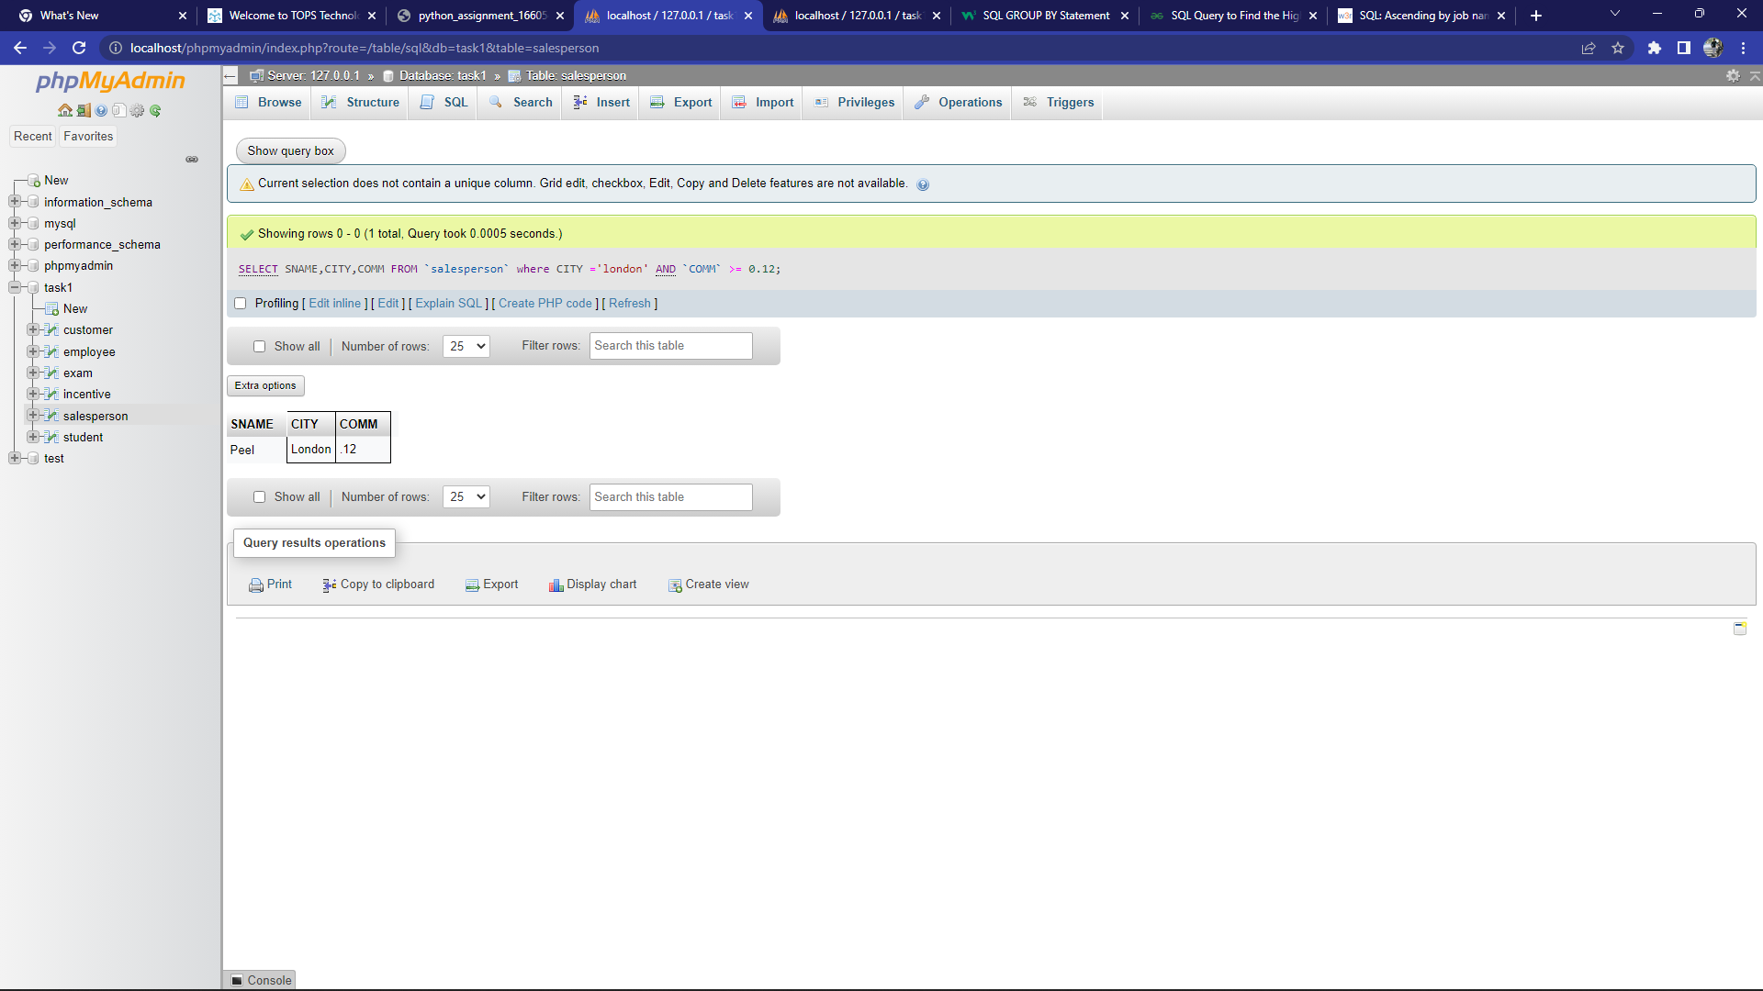

c) All salespeople either in Barcelona or in London

[SELECT](http://localhost/phpmyadmin/url.php?url=https://dev.mysql.com/doc/refman/8.0/en/select.html) * from `salesperson` where city = 'London' [OR](http://localhost/phpmyadmin/url.php?url=https://dev.mysql.com/doc/refman/8.0/en/logical-operators.html%23operator_or) city = 'Barcelona';

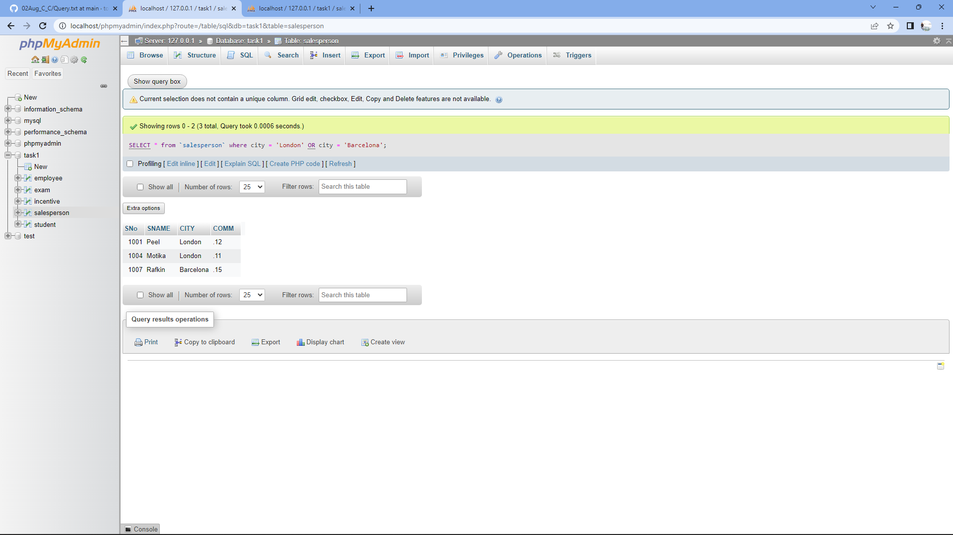

d) All salespeople with commission between 0.10 and 0.12. (Boundary values should be excluded).

[SELECT](http://localhost/phpmyadmin/url.php?url=https://dev.mysql.com/doc/refman/8.0/en/select.html) * FROM `salesperson` WHERE COMM > 0.10 [AND](http://localhost/phpmyadmin/url.php?url=https://dev.mysql.com/doc/refman/8.0/en/logical-operators.html%23operator_and) COMM < 0.12;

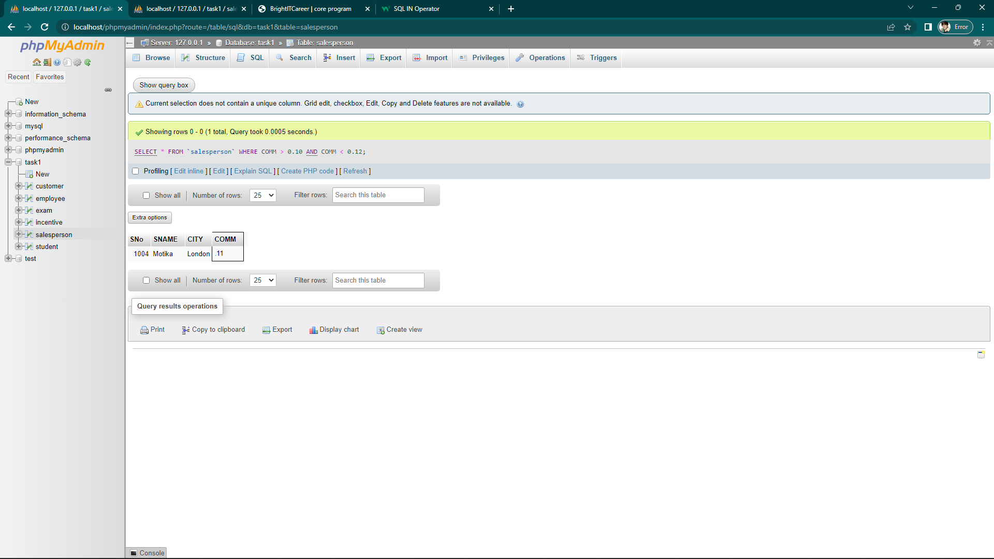

e) All customers excluding those with rating <= 100 unless they are located in Rome

[SELECT](http://localhost/phpmyadmin/url.php?url=https://dev.mysql.com/doc/refman/8.0/en/select.html) * FROM `customer` WHERE `RATING` <= '100' [AND](http://localhost/phpmyadmin/url.php?url=https://dev.mysql.com/doc/refman/8.0/en/logical-operators.html%23operator_and) `CITY` = 'Rome';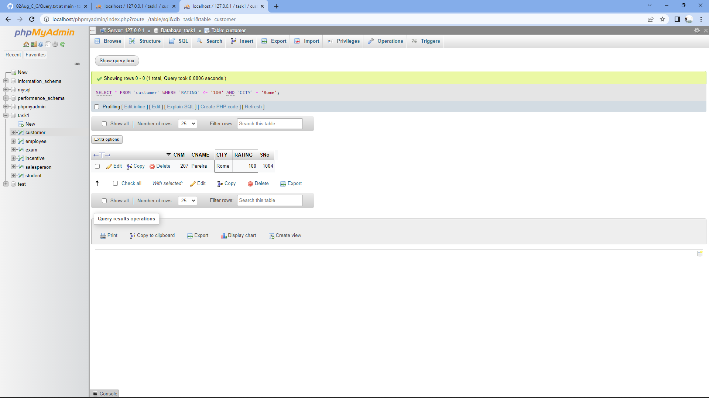

SELECT * from `table_name` where condition-1 OR condition-2 (OR)

SELECT ` column_name ` FROM `table_name` where condition-1 AND condition-2 (AND)

SELECT * FROM ` table_name ` WHERE ` column_name ` BETWEEN Range_1 AND Range_2 (BETWEEN)

SELECT * FROM ` table_name ` ORDER BY ` column_name ` ASC; (ORDER BY)

SELECT DISTINCT ` column_name ` FROM ` table_name ` (DISTINCT)

-it only work in single column

SELECT ` column_name ` MAX(` column_name ` ) FROM ` table_name ` GROUP by ` column_name ` ORDER BY MAX(` column_name ` ) ASC (GROUP BY)

ALTER TABLE `table_name` ADD FOREIGN key (`column_name`) REFERENCES `table_name` (`column_name`)

(ADD FOREIGN key)

ALTER TABLE `table_name` ADD `new_column` int(50) AFTER `column_name` (ADD NEW COLUMN)

CREATE TRIGGER `trig` AFTER INSERT ON `incentive` FOR EACH ROW

BEGIN

INSERT INTO `tanmay` set `last_name` ='add',

`email_id`=new.employee_ref_id;

END;